LLC "Baltiiskie Berega"
http://www.rosbereg.ru
Every year we solve problems in order to prevent flooding from flood and storm water to objects of road construction, roads and railways, bridges and overpasses. We ensures the protection of especially dangerous objects, residential territories, to prevent the destruction of houses. Floods cause enormous economic, social and environmental damage, incomparable with the funds spent on protective measures.
LLC "Baltiiskie Berega" have with vast experience in this field, designs and builds mobile barriers, Russian-made for flood protection, from 1.50 m to 2.4 m high, which are made from high-quality, durable and durable materials.
Simple installation and dismantling have repeatedly proved their effectiveness in the fight against flood protection. Reusable use of barriers, (50 times) takes ability to install them directly in the water significantly reduces the cost of protective measures that can be carried out at any time of the year or when the flood situation in the regions escalates.

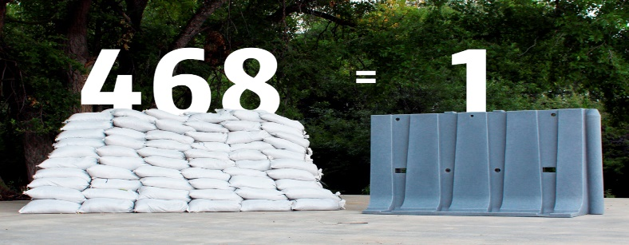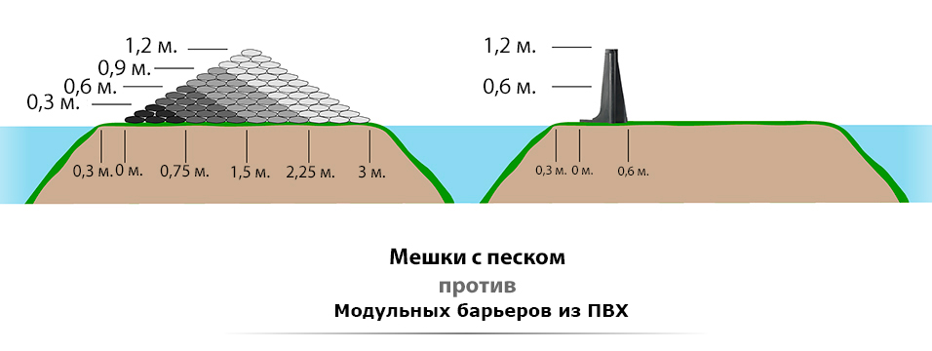

The wall structure of modular units is able to withstand the tremendous power of rushing or standing water. Patented design, in which water pressure directs the flow to the bottom, thereby create a hydrostatic force that presses the wall to the ground.
The 2.4 meter high modular block is made of low density polyethylene. This allows the product to be as well as flexible, which makes it more durable and able to withstand shock. The material is UV resistant. Barriers can be stored outdoors in any weather year-round. They do not require maintenance work and do not take up much storage space. Modular units can be easily and quickly mounted manually. Once the barriers are installed, they are quickly filled with water through openings located in the upper part of the wall. After filling with water, the weight of the block increases significantly and provides stable stability of the wall from the effects of waves. Each unit has a connector type “mother” and “father”, which is designed for quick connection with the corresponding connector of another block. There are corner, swivel elements that allow you to make connections at an angle of 90°. Using this design, you get a modern, technological solution for the protection of territories.

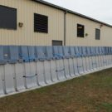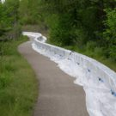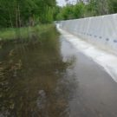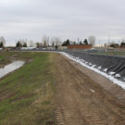
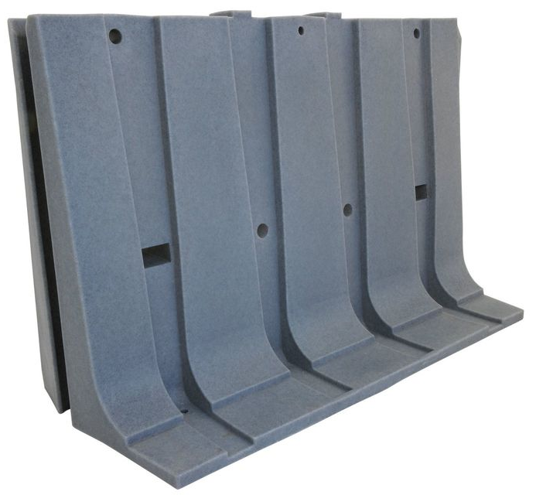

Sometimes there are emergency situations associated with the spill of oil products or when you need to quickly build a fire reservoir or reservoir of water for technical needs. This is easy to do by applying technology using our modular, protective barriers. From them it is possible to quickly build pressurized pools of various sizes both for collecting oil products and for storing water.
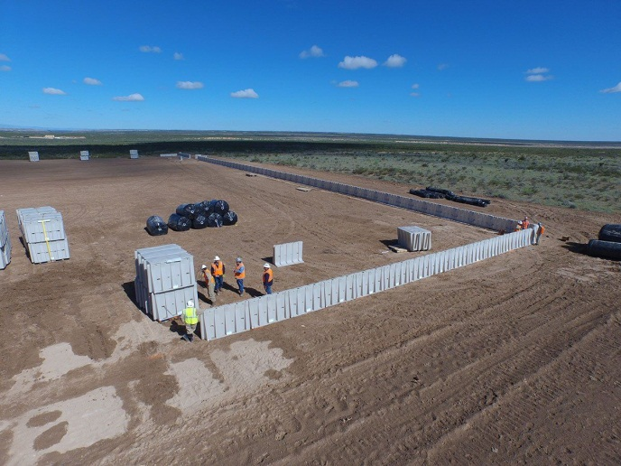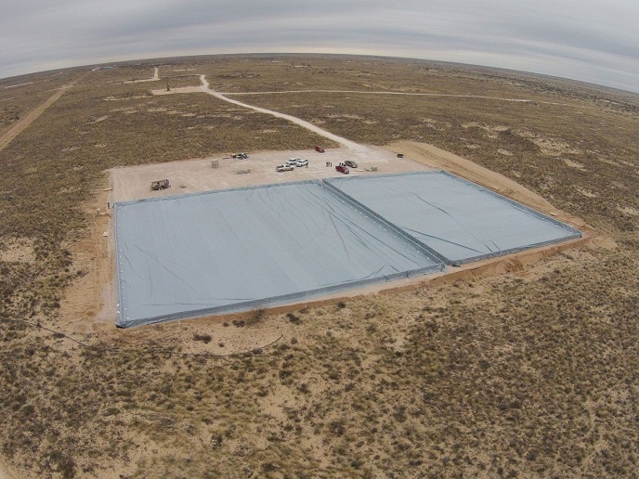
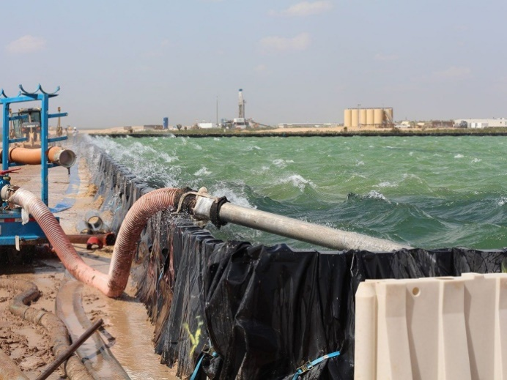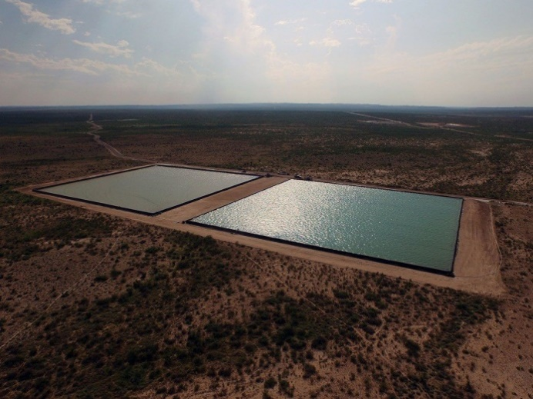
We are always ready to apply our experience and knowledge on the possible application of modern solutions to protect territories and any objects from oil spills, flood waters and floods, which are successfully used in many countries of the world.

LLC "Baltiiskie Berega"
Tel: +7 4012 377 914
Mob. +7 911 475 51 69
236023, Kaliningrad, u. Krasnya 115, office 208

